;l

Foundations of Programming

Assignment No: 8

PROBLEM STATEMENT:
Write a program in C to accept marks of five courses of a student and compute the result. A student is considered PASS if he/she scores 40 marks or more in each course. If the student passes, calculate the aggregate percentage and assign the grade as follows:
- Aggregate ≥ 75% : Distinction
- Aggregate ≥ 60% and < 75% : First Division
- Aggregate ≥ 50% and < 60% : Second Division
- Aggregate ≥ 40% and < 50% : Third Division

OBJECTIVE:
- To understand the use of conditional statements in C
- To apply logical operators for decision making
- To calculate total, percentage, and grade of a student
- To enhance problem-solving skills using real-life scenarios

THEORY:
In academic evaluation systems, student performance is assessed based on individual subject marks as well as overall aggregate performance. In C programming, such evaluation systems can be implemented using conditional statements like if, else if, and else. Logical operators help in checking multiple conditions simultaneously. Percentage calculation involves arithmetic operations, and grading logic is implemented based on predefined ranges. This program demonstrates structured programming and decision-making in C.

ALGORITHM:

1.Start.

2.Declare variables: m1, m2, m3, m4, m5, total, percentage.

3.Read marks of 5 subjects from user (m1 to m5).

4.Check if all marks are greater than or equal to 40:

5.If any mark < 40, print "Fail" and go to Step 10.

6.Calculate total = m1 + m2 + m3 + m4 + m5.

7.Calculate percentage = total / 5.

8.Display total and percentage.

9.Assign grade using conditions:

If percentage ≥ 75 → Print "Distinction".

Else if percentage ≥ 60 and < 75 → Print "First Division".

Else if percentage ≥ 50 and < 60 → Print "Second Division".

Else if percentage ≥ 40 and < 50 → Print "Third Division".

10.Display the result.

11.Stop.

FLOWCHART:

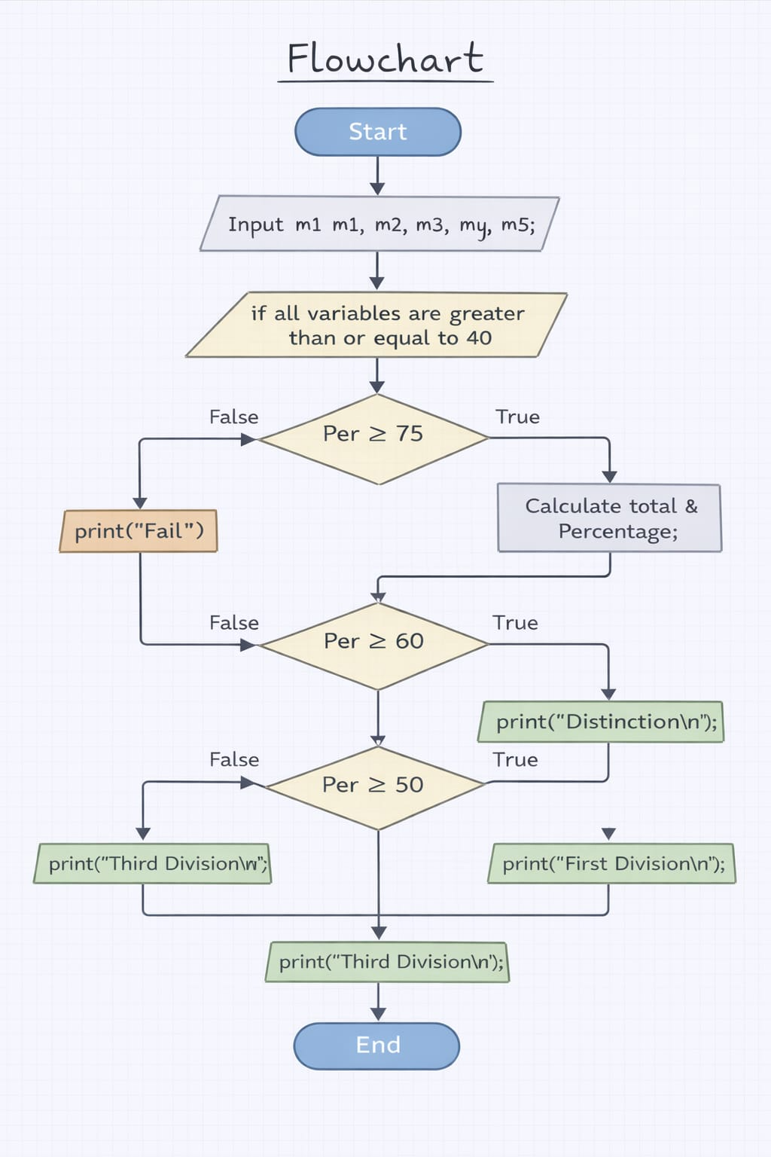

PLATFORM: Linux
PROGRAM

INPUT:
The user enters marks of five subjects.

#include <stdio.h>

int main() {

float m1, m2, m3, m4, m5;
float total;
float percentage;

printf("Enter marks of first subject: ");
scanf("%f", &m1);

printf("Enter marks of second subject: ");
scanf("%f", &m2);

printf("Enter marks of third subject: ");
scanf("%f", &m3);

printf("Enter marks of fourth subject: ");
scanf("%f", &m4);

printf("Enter marks of fifth subject: ");
scanf("%f", &m5);

if (m1 >= 0 && m2 >= 0 && m3 >= 0 && m4 >= 0 && m5 >= 0) {

total = m1 + m2 + m3 + m4 + m5;
percentage = (total / 500) * 100;

printf("Total marks = %f\n", total);
printf("Percentage = %f\n", percentage);
}

if (percentage >= 75) {
printf("Distinction");
}
else if (percentage >= 60 && percentage < 75) {
printf("First Class");
}
else if (percentage >= 50 && percentage < 60) {
printf("Second Class");
}
else if (percentage >= 40 && percentage < 50) {
printf("Pass");
}
else {
printf("Fail");
}

return 0;
}

OUTPUT:
Enter marks of first subject: 67
Enter marks of second subject: 77
Enter marks of third subject: 88
Enter marks of fourth subject: 76
Enter marks of fifth subject: 56
Total marks = 364.000000
Percentage = 72.800003
First Class

CONCLUSION: Thus, the program to calculate student result and grade based on marks was successfully implemented using C programming. This program demonstrates the effective use of conditional statements, logical operators, and arithmetic operations.

FAQs:
- What is the objective of this C program?
- Why is an if–else ladder used in this program?
- Which data types are generally used in this program?

